Counterfactual Inference Using Time Series Data
In this article, we’ll explore a powerful causal inference technique that I believe every data scientist should have in their toolbox.
Press enter or click to view image in full size
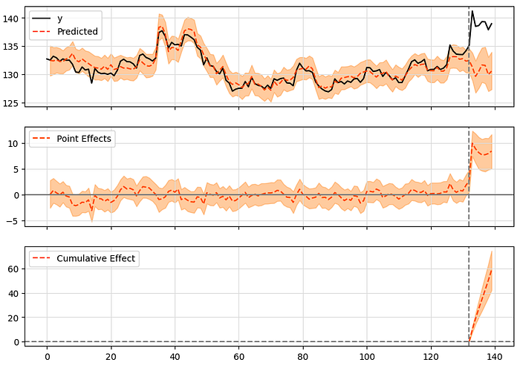
tfcausalimpact
This article has six sections:
1) Introduction
2) Quick Causal Inference Primer
3) Brief Description of Causal Impact Algorithm
4) Applications of Counterfactual Inference with Time Series Data
5) Demo in Python, Using tfcausaimpact Package
6) Conclusion
The full project and all code can be seen in my github repository.
ThatShelbs / CausalInferenceTimeSeries
1) Introduction
Are you ever curious about the true impact of a new marketing campaign, product launch, new government policy, or some other event? Wouldn’t it be nice if you could compare the results of the event occurring versus never occurring at all? Well, with counterfactual inference using time series data, you can do just that! And the best part? You don’t need to be an actual time-traveling wizard — just a few lines of Python code from the tfcausalimpact package will suffice.
In this article, we’re going to take a deep dive into counterfactual inference using time series data. We’ll start with a quick primer on causal inference, followed by some real-world applications of counterfactual inference with time series data. And finally, we’ll wrap things up with a demo in Python, using the tfcausalimpact package.
By the end, you’ll have a solid understanding of this powerful technique and the tools you need to start using it in your own data science projects. So grab a cup of coffee and let’s get started!
2) Quick Causal Inference Primer
Before we dive in to CausalImpact analysis, let’s make sure we’re all on the same page. Here are five must-know things about causal inference to kickstart our journey.
1. What is causal inference?
Causal inference is the process of determining cause and effect between variables.
It is a much more powerful insight than just doing a feature importance analysis or slicing and dicing your data in a dashboard. When causal inference is done right, there is a deeper understanding of why things are happening. With this understanding there is much more clarity on what actions need to be taken moving forward to best control the outcomes you care about (e.g. this new website version we launched did truly cause sales transactions to increase, so now let’s roll out the new website to everyone).
I am pretty sure Uncle Ben in Spiderman once said, “With great causal inference comes great power.”
Speaking of overused sayings, lets move on to #2.
2. Correlation does not equal causation.
Correlation does not equal causation, it’s the “don’t judge a book by its cover” cliché of statistics. It’s like when you hear the same old story from your grandpa for the millionth time. But maybe grandpa is telling the story because it is a lesson worth remembering.
The story of correlation is a cautionary tale. Correlations can mislead us into overconfidently drawing poor conclusions from the patterns we are seeing in the data. For instance, there may be a correlation between a company’s marketing spend and its sales. However, this does not necessarily mean that increased marketing spend directly causes more sales. For example, it could be that the marketing spend is planned and executed for the times of year when demand is already high.
3. Random Controlled Trials (RCTs) are the gold standard
RCTs are when the subjects are randomly assigned to groups. A well known variant of RCT is called the A/B test. They are known as the most rigorous and best practice in determining causality.
The key principle is the randomly assigned groups where some people receive a treatment and others do not. When subjects select their own groups it can often introduce bias and other confounds. Random assignment will ensure better isolation of the one thing that we are interested in testing for causal impact.
For the remainder of this article I will use experiments, tests, and RCTs interchangeably.
4. Random Controlled Trials (RCTs) are not always feasible or desirable
Although RCTs give us a clean way to analyze causal impact, they have their own set of drawbacks and limitations. There are many reasons why RCTs are not always feasible or desirable, for today, I am just going to share three reasons:
- RCTs can be costly or resource intensive. For example, marketing data scientists might recommend to hold out some percentage (e.g. 5%) of their customer base for marketing campaigns to measure the lift from the activity. If the marketing treatment works there could be lost sales from not marketing to those potential customers. There is also risk and cost associated to the set up, execution, and measurement of the experiment.
- Experiments often lack “always-on” measurement since they tend to have specific start and end dates. This conflicts with businesses’ need for up-to-date data and dynamic-decision making. Once an experiment ends, it becomes unclear how long the experiment insights should be used before another experiment needs to occur. I once witnessed a company using marketing experiment results that were over 5 years old, which was problematic as the digital marketing landscape had significantly evolved since then.
- Random assignment in experiments can lead to unfair or unethical outcomes. For instance, it would be unjustifiable to deny certain children access to additional resources while others receive them based solely on random assignment. Similarly, in a business context, there can be pushback from sales teams regarding the allocation of resources.
Luckily, there is active research and techniques being developed that are designed for when you cannot do an RCT. Such as the technique we are going to explore below! Are these techniques always perfect, easy to execute, and more precise than an RCT? That is a negative. As mentioned, experiments are the gold standard and it is difficult to conceive that changing anytime soon.
5. Causal inference problems can be much more challenging than machine learning problems
In machine learning, we use Xs to predict Y and correlations are all we need to do a good job. When you are trying to understand the impact of some treatment T on Y given Xs things get a little tricker. We have to worry about factors that could impact both T and Y (confounds) tricking us into thinking T is causing Y when it is actually not.
A second challenge is that in machine learning, we have our ground truth labels available (Y). So model validation procedures are actually very straightforward. Just keep holdout datasets the model has never seen before to test the model performance. In causal inference, we can only see half the scenario we are trying to measure. For example, I cannot treat someone then not treat them.
Important for later, the scenario that doesn’t occur in reality but can be simulated is called the counterfactual.
Alright, now that you have some fundamentals of causal inference under your belt. Let’s move on to a powerful causal inference technique that involves time series data called CausalImpact.
3) Brief Description of CausalImpact Algorithm
What does CausalImpact do?
Given some sort of isolated event with a known start date, CausalImpact allows us to measure the incremental impact on an outcome we care about.
Such as launching a marketing campaign in one city and understanding if the marketing campaign caused an increase in sales.
How does CausalImpact work?
CausalImpact allows us to build a counterfactual time series that simulates the reality in which the event did not occur. By comparing and contrasting what actually happened to our simulated scenario we can assess the impact between actual and counterfactual.
The algorithm achieves this by:
- Using machine learning to build a Bayesian structural time series (BSTS) forecast using test and control time series
- Using causal inference by blending this result with new (post-period) trends experienced by control time series
Think about the shortcomings of using just machine learning or just causal inference. If we just build a machine learning forecast we would be ignoring the potential for some new macro trend such as changes to the economy or outlier weather events. If we disregarded machine learning we miss out on nuanced patterns that are established in the pre-period across our test time series and control time series.
In other words, by utilizing both machine learning and causal inference concepts we are able to build the most realistic counterfactual scenario possible.
Also, as you can see the control time series is key to making this analysis work. The good news is that you can add many control time series, you aren’t just limited to one. You can also use time series of metrics or values that aren’t the same as the test time series. As long as the event did not effect the control time series it is fair game!
CausalImpact algorithm origin
Google Open Source Blog announced CausalImpact as an open-source R package September 10, 2014.
A companion research paper was posted in 2015 crediting Kay H. Brodersen, Fabian Gallusser, Jim Koehler, Nicolas Remy, Steven L. Scott.
Besides the R package, there are two python ports currently available. causalimpact and tfcausalimpact. tfcausalimpact, the package we will use today, is written on top of TensorFlow Probability. There is a medium article written by the package creator and maintainer (Will Fuks) if you want to dive deeper into the ideas and concepts behind the library.
3) Applications of Counterfactual Inference with Time Series Data
Three example applications for CausalImpact
- You want to understand the marketing impact on sales by placing billboards throughout a city
- Recreational usage of marijuana is legalized in a specific state and you want to see if there is a noticeable impact to the number of traffic accidents
- An isolated incident happens to just one company and you want to see how that impacted the stock price
When you should use this technique
As you can tell in the previous examples, these are some themes that should get you thinking about using the causalimpact algorithm:
- There is some sort of event (launch, incident, pilot, etc.) and you are aware of when it started
- The event is reasonably isolated (perhaps to a geographic territory) so you have the ability to construct both a test and control time series (such as comparing the impacted geographic territory to the non-impacted geographic territories)
- The event should have a significant impact on the outcome variable you are interested in. Putting one measly billboard in a city and attempting to measure impact to sales in the entire city = BAD IDEA. Put 10 billboards in a city and measure impacts to sales for the entire city = BETTER IDEA. You are in effect trying to pick up a signal using the time series of an entire city. This is a less precise instrument than if you were somehow able to filter down to those individuals who saw the billboard and those who did not.
When you should not use this technique
You need a very precise measurement of causal impact and a randomized controlled trial (RCT) is feasible.
You cannot confidently gather both test and control time series.
5) Demo in Python, Using tfcausaimpact Package
By the end of this section, you should be able to run your own causalimpact analysis.
Introducing the problem we will solve
For the demo, we will assess the causal impact to stock price when Salesforce announced a 10% workforce layoff at early morning hours on January 5th, 2023.
(For the record, yes I worked for Salesforce during this layoff announcement and no I was not involved in the layoff)
The full tutorial to recreate these results can be found in my github repository.
Discovery and exploratory data analysis
Since this is a public news event before even pulling our own data lets check the news to see what was reported about the layoff announcement and the stock price.
Here are five articles
- Seeking Alpha: Salesforce is up 1.8%
- Motley Fool: Salesforce is up 3%
- Investor place: Salesforce is up 5%
- Reuters: Salesforce is up 3%
- CNN: Salesforce is up 3%
Based on these articles alone it seems like the stock price might have increased by 3%.
Now let’s get some data to work with. We will use yfinance and yahooquery to pull stock data. I end up pulling all the data with the yfinance API but then I found it easier to pull the company names using yahooquery API.
Press enter or click to view image in full size
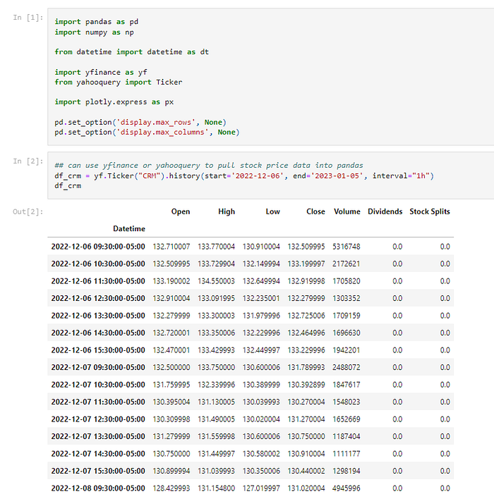
I decided to pull 20 days of data on the stock price with a price reading every hour. Since the US stock market is open from 9:30am to 4:00pm EST. We get 7 price reading datapoints a day.
For the 20 days of data that is 140 observations in the time series. I decided to pull 19 days for the pre-period leading up to the layoff announcement. Then just 1 day after the layoffs were announced.
These decisions can be initially driven by what we know and then later justified with more data driven approaches.
As a casual follower of stocks, I’ve noticed when news breaks the stock market’s reaction is often very immediate. Let’s take a look at how the price of Salesforce, ticker CRM, actually moved leading up to and after the layoff news.
Press enter or click to view image in full size
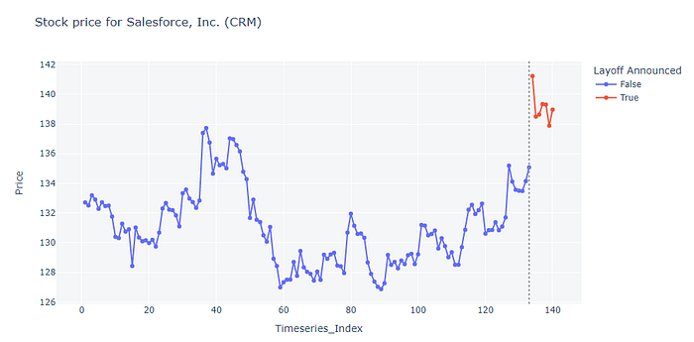
From visual inspection it definitely seems like there was some sort of jump when the news broke.
We can compare the mean price from the day prior to the mean price for the day after the layoff news.
Press enter or click to view image in full size
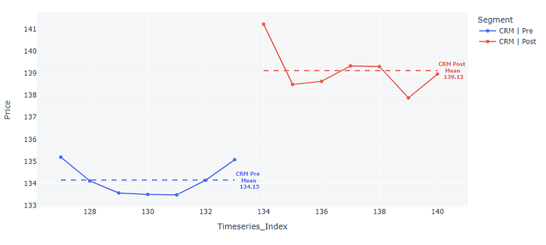
Percent change: ($139.12 — $134.15) / $134.15 = 3.7%
A pre-period, post-period comparison seems to get us really close to what was reported by various news outlets. However, there are some reasons why pre-post analysis might not be good for causal inference:
- What if the stock market had a bad day and 95% of stocks in the S&P 500 decreased by 2% on January? CRM, a member of the S&P 500 likely would have also decreased as well. In this scenario, perhaps the impact from the layoffs was greater than what pre-post analysis measures because it doesn’t consider macro trends.
- For CRM stock price we can also consider the patterns and trends within that time series. In the pre-period, CRM stock price was on an upward trend the 12 days preceding the layoff announcement. Based on this information, perhaps CRM stock price was actually going to continue to trend upward. This would mean the impact from the layoff announcement was actually less than the 3.7% we measured. Pre-post analysis doesn’t consider temporal patterns or trends leading up to the event either.
If only we had an algorithm that helped us incorporate temporal patterns and macro conditions… Oh wait. We do.
CausalImpact
As mentioned previously, we will need more than just our test time series (Salesforce CRM price data). We need isolated control time series data as well. For this demo we will make a basket of controls using similar companies that are in technology, cloud, and B2B software.
Test Time Series
Salesforce (CRM)
Control Time Series
Microsoft (MSFT)
Adobe (ADBE)
Oracle (ORCL)
ServiceNow (NOW)
Workday (WDAY)
Hubspot (HUBS)
Monday (MNDY)
Atlassian (TEAM)
Snowflake (SNOW)
Although, it is reasonable to assume that a layoff announcement will not significantly impact the stock price of other companies — Technically, it is possible for a layoff announcement to create some incentive to buy or sell competitor stocks but at least for the scope of this demo we can assume it doesn’t. In practice, this is a reminder to be sure to work with your stakeholders and subject matter experts to make sure the assumptions you are making are valid.
One might also consider adding indexes such as VTI, VOO, and IGA as controls. They could be useful for getting a good idea of how large baskets of stocks moved throughout the day. However, these baskets of stocks contain our test stock Salesforce (CRM) therefore would contain some impact from the layoff announcement. This could invalidate the credibility of the analysis.
Here is a basic loop through the basket pulling the hourly stock price data for all the stocks.
Press enter or click to view image in full size
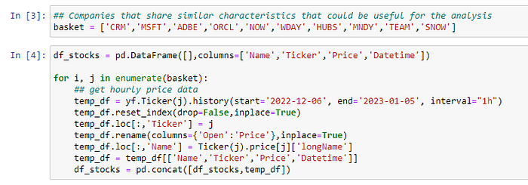
Now, we can:
- Calculate the relative price movements from t0 = 1. In other words, for each stock, we anchor on the price of the very first reading so that it is equal to 1 and all the subsequent movements are on the same scale.
- Next visualize CRM relative stock price vs the mean relative stock price of our basket.
Press enter or click to view image in full size
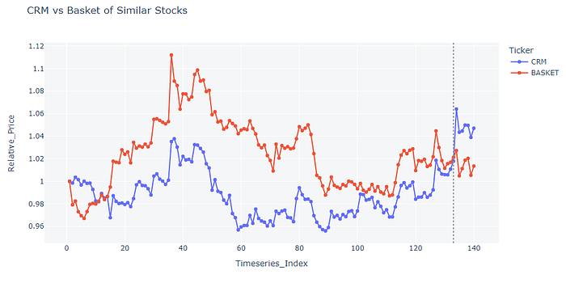
Visually it looks like the movements do tend to correlate in the pre-period. We can go ahead and just plot this out and calculate R2.
Press enter or click to view image in full size
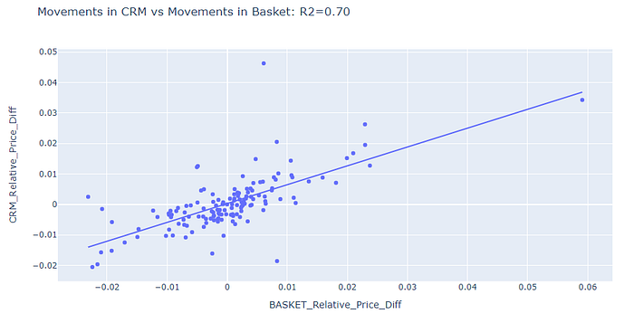
In the pre-period we can explain 70% in the variation of Salesforce CRM stock price movement with the custom basket we created. This is desirable for helping CausalImpact create a realistic counterfactual.
It is time for the big moment, lets make a wide version of the stock data where one column is the stock prices. Then pass it to causalimpact specifying the pre-period and post-period.
Press enter or click to view image in full size
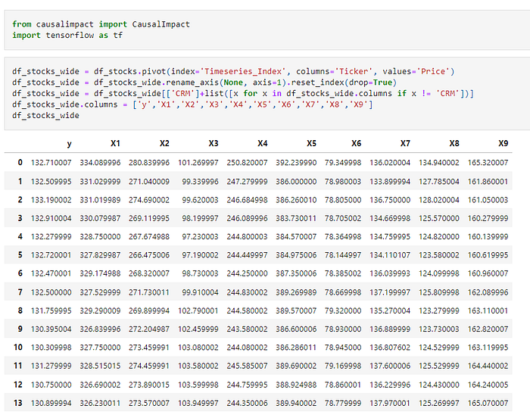
Press enter or click to view image in full size
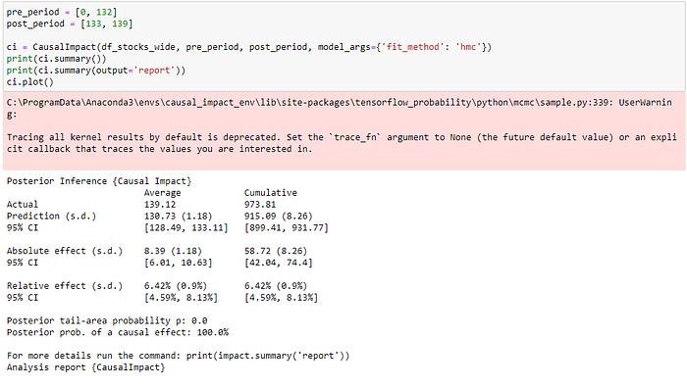
What you will notice first is a printed report. In our specific problem we are most interested in the relative effect and can see an impact of 6.42%.
If we were tracking something like sales we might also be interested in the cumulative absolute effect which is the causal impact summed up across the entire post period. It doesn’t make much sense to do this for a stock price.
Since this is a bayesian structural time series algorithm we also get a conficence interval out of the box. We can see that we are 95% sure the causal impact is between 4.59% and 8.13%.
The report goes on to summarize the results further. At least for our demo, its time to move onto the plot.
Press enter or click to view image in full size
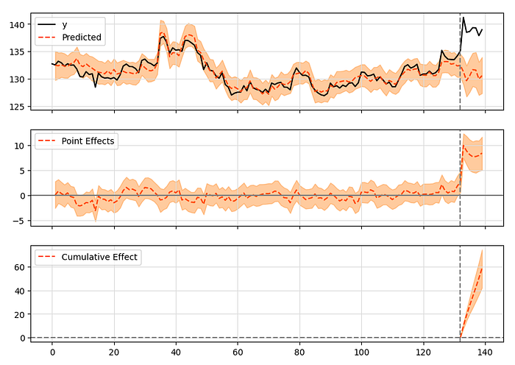
We get three plots from causalimpact. The first one shows actual vs our synthetic counterfactual. In our specific case, we are seeing the actual increase after the event and if we did nothing we actually could have expected CRM to perhaps decrease a little bit. This can be verified by our basket that similar stocks did tend to decrease a little bit on January 4th, 2023.
After all of this, we can disregard all the news outlets that reported around 3% change and more confidently accept that:
- CRM stock price likely would have decreased slightly if there was no layoff announcement
- It overcame this expected decrease, resulting in an overall 6.4% price increase
- This is a much different result than what the news outlets reported (3%), probably because they used pre-period post-period comparisons only
Validating the Results
We built a solution and it seems very promising, but how do we quantitatively demonstrate if the solution is amazing, good, or nightmarishly awful?
Other related questions I often hear surrounding this analysis include:
- Did we use enough pre-period data?
- Did we grab enough control features?
- Did we grab too many control features?
- Did we grab the right control features?
- Could transformation to control features result in a better solution?
Unfortunately, the causal impact packages out there don’t seem to have a rigorous built in approach to answer all of these questions. But don’t stress! I got you covered with a helper function I wrote that we can use.
Just like in a typical machine learning project, it is a best practice to explore a few different solutions and then pick the best one based on an objective performance metric.
For the reminder of the demo, let’s explore four different solutions:
- Current solution
- Challenger solution 1: Triple the training data size
- Challenger solution 2: HMC algorithm (a slower but better algorithm than the default Variational Inference algorithm the package uses)
- Challenger solution 3: HMC algorithm and triple the training data size
Back-testing Analysis:
What we cannot do is assess model fit errors using the post-period data because some event occurred and so we often expect the event to cause our counterfactual forecast and actual result diverge.
In other words, the difference between the counterfactual forecast and the actual result is the causal impact estimation from the event occurring.
What we can do for model validation in causal impact is ignore the post-period, then take a fraction of the end of pre-period data and use that for validation. The idea would be to see how well the counterfactual forecast aligns with actual when there is no treatment.
Press enter or click to view image in full size
Won’t be able to use the post-period dataset for validation
Press enter or click to view image in full size
Instead use some fraction of the end of the pre-period data as a holdout for validation
The helper function I created will:
- Randomly draw different back-testing cuts of the pre-period data and run many trials for a given solution
- Builds causal impact algorithm to assess if the counterfactual forecast makes sense
- Has optionality to still print out the plots for a visual inspection of the back-testing exercise (remember in these plots you actually want to see the actual and counterfactual forecast align with eachother)
- Finally, the helper function reports MSE and R2 for error metrics and returns a data frame with train and holdout results
Here is the helper function:
def ci_backtesting_analysis(wide_df, number_of_evals, pre_period, post_period, alpha, print_plots=True, fit_method='vi'):
"""
wide_df - the dataframe you would run causal impact on, make sure dependent variable time series is in column number 0
number_of_evals - the number of times you want to build a casual impact analysis and check the error
pre_period - the real pre preiod
post_persion - the real post period, this data will not enter the backtesting analysis
alpha
print_plots
"""
# a dataframe that will hold results
results = pd.DataFrame([],columns=['Evaluation','train_RMSE','test_RMSE','train_r2','test_r2'])
# filter data frame of post_period because we won't use it in analysis
wide_df = wide_df.iloc[pre_period[0]:(pre_period[1]+1),:]
#loop through the number of evals
for i in list(range(0,number_of_evals)):
## copy wide_df for reloading
temp_wide_df = wide_df.copy()
# create a new pre post range from the pre_period
# select a new random pre-period start date in the first 25% of the pre period
pre_start = int(np.random.choice(list(range(pre_period[0],int(pre_period[1] * .25)))))
# select a new random post-period start in the between the last 60% and 80% of the pre period
post_start = int(np.random.choice(list(range(int(.70*pre_period[1]),int(.85*pre_period[1])))))
pre_end = post_start - 1
# select a new random post-period end in the between the last 60% and 80% of the pre period
post_end = int(np.random.choice(list(range(int(.90*pre_period[1]),pre_period[1]))))
pre_obs = (pre_end-pre_start)
post_obs = (post_end-post_start)
print("Backtest Trial {}: pre-start {}, pre-end {}, post-start {}, post-end {}".format(i,pre_start,pre_end,post_start,post_end))
temp_wide_df = temp_wide_df.iloc[pre_start:(post_end+1),:]
temp_wide_df.reset_index(drop=True, inplace=True)
pre_start = 0
pre_end = pre_obs
post_start = pre_obs+1
post_end = pre_obs+1+post_obs
pre_period_new = [pre_start,pre_end]
post_period_new = [post_start,post_end]
if fit_method == 'hmc':
ci = CausalImpact(temp_wide_df, pre_period_new, post_period_new, alpha = alpha, model_args={'fit_method':'hmc'})
elif fit_method == 'vi':
ci = CausalImpact(temp_wide_df, pre_period_new, post_period_new, alpha = alpha, model_args={'fit_method':'vi'})
else:
print('Provide fit method: hmc or vi')
y_train_true = ci.data.iloc[pre_start:(pre_end+1),0]
y_train_pred = ci.inferences.iloc[pre_start:(pre_end+1),0]
y_test_true = ci.data.iloc[post_start:(post_end+1),0]
y_test_pred = ci.inferences.iloc[post_start:(post_end+1),0]
# get train RMSE
train_RMSE = mean_squared_error(y_train_true,y_train_pred)
# get test RMSE
test_RMSE = mean_squared_error(y_test_true,y_test_pred)
# get train r2 score
train_r2 = y_train_true.corr(y_train_pred)
# get test r2 score
test_r2 = y_test_true.corr(y_test_pred)
results.loc[i,'Evaluation'] = i
results.loc[i,'train_RMSE'] = train_RMSE
results.loc[i,'test_RMSE'] = test_RMSE
results.loc[i,'train_r2'] = train_r2
results.loc[i,'test_r2'] = test_r2
print(" Test RMSE: {:.2f}, Test R2: {:.2f}".format(test_RMSE,test_r2))
if print_plots==True:
ci.plot()
else:
pass
mean_test_rmse = results['test_RMSE'].mean()
mean_test_r2 = results['test_r2'].mean()
print("")
print("{} Evaluations Completed | Mean Test RMSE {:.2f}, Mean R2 {:.2f}".format(number_of_evals,mean_test_rmse,mean_test_r2))
return results
We will run the function for 10 times across our current solution and three challenger solutions.
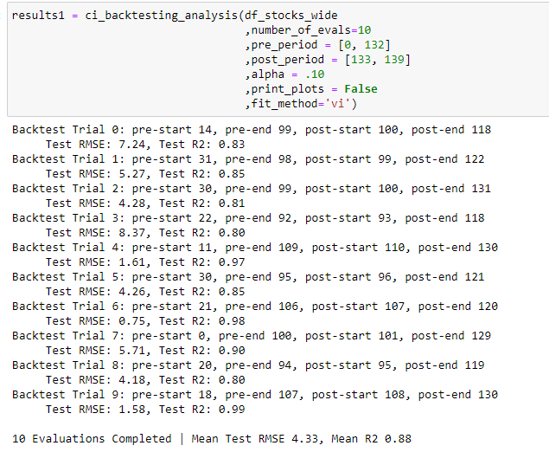
This is a screenshot of the current solution being run in the back-testing helper function.
We can use plotly to bar chart out RMSE and R2.
Press enter or click to view image in full size
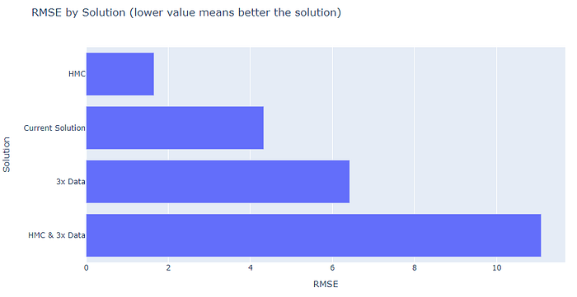
Press enter or click to view image in full size
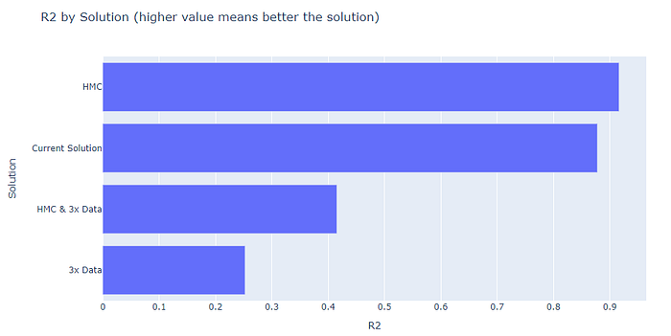
In conclusion, challenger solution 2: HMC Algorithm, seems to be the best solution. Adding additional data to train on actually seemed to make CausalImpact perform worse. If we wanted to keep going maybe we could try to 3x the data AND try removing control features that seem to be noise when conducting EDA.
If we are happy with all the solutions we tried thus far, then the next step is to go ahead and rerun CausalImpact again with the winning approach in place of the old approach.
Other validation steps to try
Inspect the CasualImpact parameter weights
For the question, did I grab too many features or the right features? CausalImpact algorithms tend to be able to give you some insight into this question out of the box. For tfcausalimpact, you can print out the coefficient weights and get an idea on how the model might be using the different control features (or not using them very much at all).
Press enter or click to view image in full size
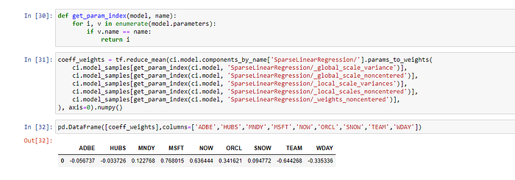
In this model it looks like Microsoft (MSFT) and Service Now (NOW) provided strong positive weights in building the counterfactual. Atlassian (TEAM) ended up having a stronger negative weight. Then Adobe (ADBE), Hubspot (HUB), and Snowflake (SNOW) did not provide weights in either direction with results close to zero.
Univariate Correlation Analysis
This is an exploratory data analysis (EDA) step you can do to get some further understanding of the the control time series we have.
Keep in mind this is a univariate analysis where the model and complexity of reality is not just considering one variable in a silo. Nonetheless, this can still provide a hint on what time series might not be helpful. However, it shouldn’t be conclusive because in a multi-variate setting that can change.
In our project, we can build a correlation heat map then focus on the CRM row or column.
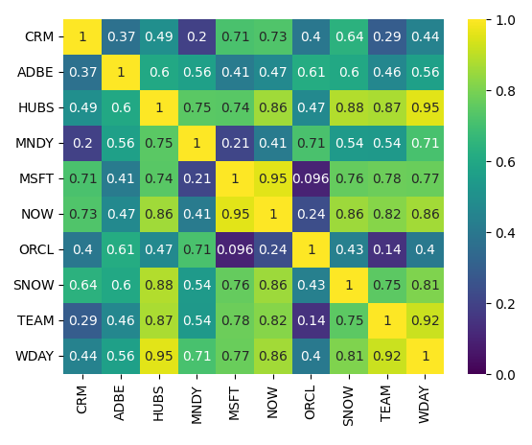
After looking at the models coefficient weights, it is also not surprising that Microsoft and Service Now had strong positive correlations. In the multivariate modeling setting we also saw these two provide strong positive weights.
Seeing the similarities and hints between the model we built in the prior section and this univariate view can sometimes help demonstrate further validation with stakeholders who think the model is myterious and hard to interpret.
Cross check the results with difference-in-differences
Difference-in-differences is essentially the great grandfather to the causal impact algorithm. There is nothing stopping us from trying out this old but reliable approach to get another number to triangulate on.
Press enter or click to view image in full size
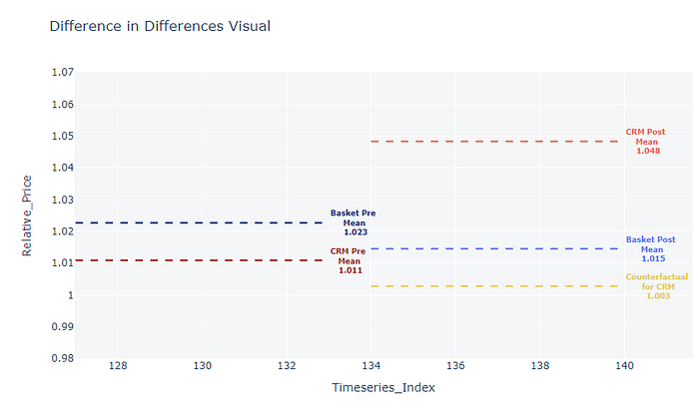
It looks at the data in aggregate for pre and post. Here the dark blue line (basket pre mean) is the average price change for our control basket of stocks benchmarked to the beginning of our dataset. The interpretation is, of the stocks in our control basket in the pre period they were up by about 2.3% from the first date in our data.
We can see the control basket in the post area decreased from 1.023 to 1.015 (see the lighter blue line). We can conclude our control basket decreased by .8% on average.
The major assumption in difference-in-differences is that without any intervention we would have expected CRM pre mean (the dark red) to also decrease by .8% on average. This gives us the yellowish gold line. So our expectation for CRM would actually be 1.003. This serves as a counterfactual. Finally, we can compare the gold line to the actual post to calculate a causal impact from the intervention.
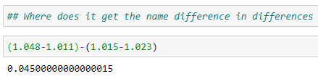
As a recap:
- pre-post gave us 3.5%
- difference in differences gave us 4.5%
This makes sense because the control basket decreased. Therefore CRM overcame an expectation of decreasing if there was no layoff announcement and still increased 3.5% from the prior day on top of that.
Principal Component Analysis
In the event of having hundreds or thousands of potential controls it is worth bringing up dimensionality reduction solutions such as PCA to reduce or project our features to a narrower but more refined set of controls. Personally, I like to do PCA to just inform us which controls are redundant rather than using the projections.
Just another thing to be aware of when running causal impact projects. Here are some links to get started on that:
PCA in Scikit-learn — Principal Component Analysis (with Python Example)
Principal component Analysis | Python
Introduction to Factor Analysis in Python
6) Conclusion
Using the CausalImpact algorithm, we gathered that our common media outlets likely were not reporting accurate casual impact numbers from the CRM layoff announcement. In other words, they were likely underreporting how much the announcement positively impacted the stock price that day. We also modeled the casual impact results in a time series structure which allows us to see how the impact evolved over time post CRM layoff announcement.
I think I rest my case that CausalImpact is a very handy solution that every data scientist should know. And, if you actually read the article and didn’t just skim read, you are now more than ready to bring this approach into your projects!
I appreciate the read and hope this was very informative and helpful for your own causal inference needs!

